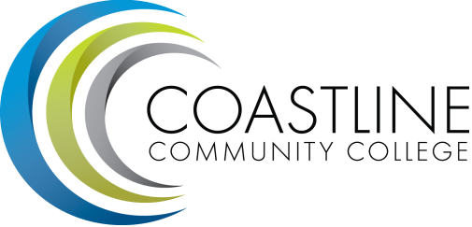

Classified Senate Meeting Minutes
February 19, 2015
10 am to 12 pm
College Center, 4th floor conference room

Approval of Minutes (5 minutes):

Fundraising Update (10 minutes):
  - PaintsUncorked

College-wide Agenda format (10 minutes):

Committee Reports (10 minutes):

Hot Topics (10 minutes):
  - Angel game.

Next Meeting: March 19, 2015

